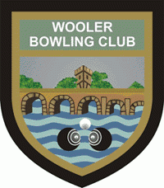
Wooler Bowling Club
The Green 2-4 Weetwood Road Wooler
Invite you to our OPEN DAYS
Sunday 30th May and
Monday 31st May from
1.00 p.m. to 5.00 p.m.
Come Along and HAVE A GO!
Bowls and Bowling Shoes provided by the Club
Sporting Activities in the Clubhouse
if the weather is inclement
Bowls is the Sport for All Ages
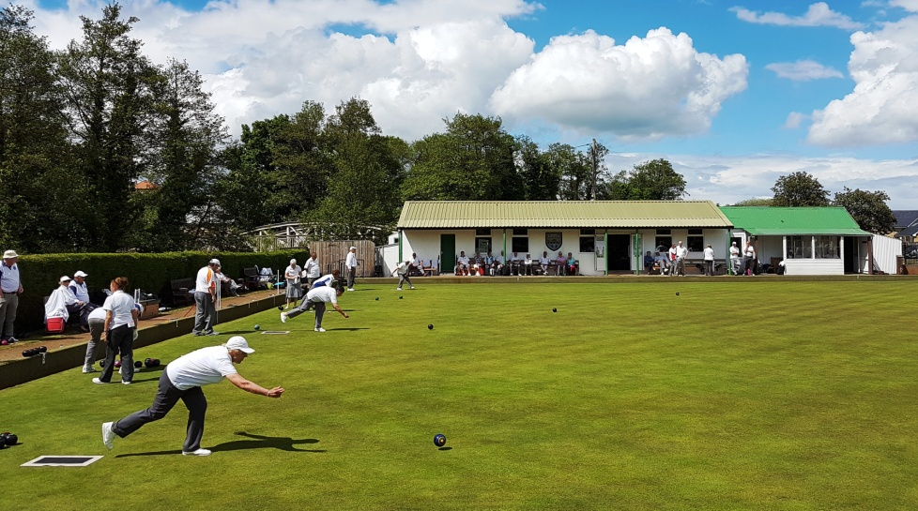
Enquiries to: Richard Henthorn: 07867 524246
Maurice Ward: 07704 329232
John Guthrie: 07733 662545

