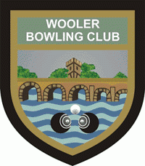
Wooler Bowling & Sports Club
2-4 Weetwood Road, Wooler NE71 6AE
Invite you to an OPEN DAY
Sunday, 28th April 2024
1.00 p.m. to 5.00 p.m.
Come along and Have A Go
Bowls and Bowling Shoes provided by the Club
Refreshments & Activities in the Clubhouse
Bowls is the Sport for All Ages
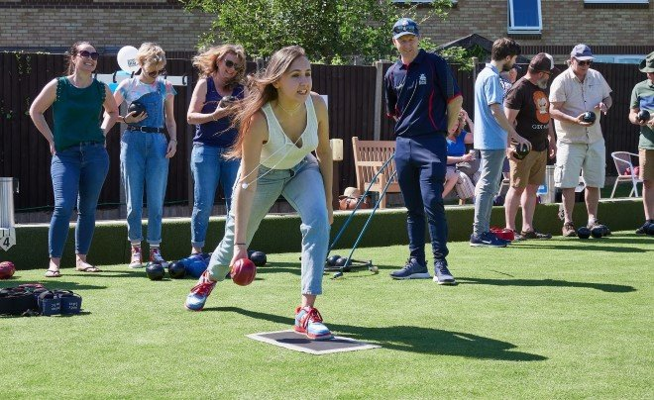
Enquiries: Richard Henthorn 07867 524246
or Maurice Ward 07704 329232
e-mail: woolerbowlingclub@btinternet.com
Visit our Website: www.woolerbowls.co.uk
Follow us on Facebook

